# Lab-6-1: Azure Networking

# Objectives

* create two VMs on Azure and establish networking within them
* create and Manage network Security groups



**Part 1: Exercises**

**Exercises 1: Creating Virtual Network, Subnets and VMs**

You will do these exercises on the new resource group created for you

1. In this exercise you are going to do the following:

*Create virtual network and BastionHost*

1. Create a Virtual Network: <yourfirstname>vn 10.1.0.0/16
2. Create a sunet: <yourfirstname>subnet 10.1.0.0/24
3. Enable BastionHost under security tab:

* bastion subnet 10.1.0.0/24,
* name <yourfirstname>BastionHost
* PublicIP: <yourfirstname>BastionIP

**Create Virtual machine VM1**

1. Name: <yourfirstname>VM1
2. Public inbound ports: None
3. Virtual network: <yourfirstname>vn
4. Subnet: <yourfirstname>subnet

**Create another Virtual machine VM2 like above**

**Connect to VM1 using Bastion**

**Ping VM2 from VM1**

**Q1. Paste the ping execution screenshot.**

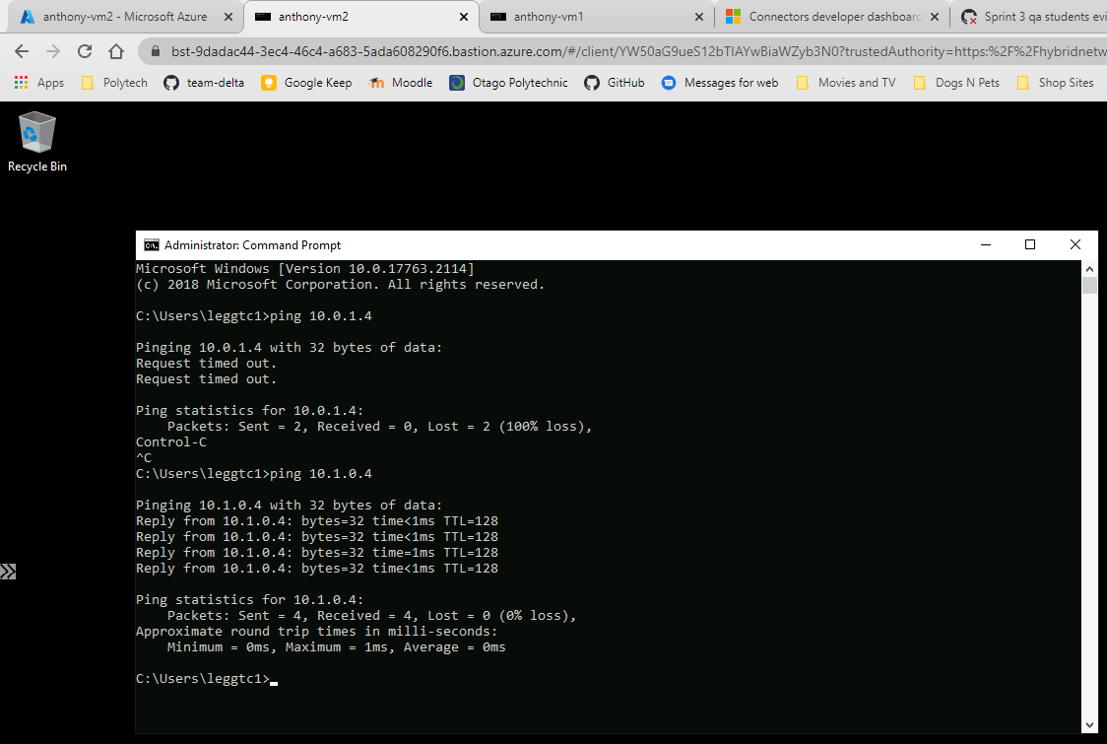

**Ping VM1 from VM2**

**Q2. Paste the ping execution screenshot.**

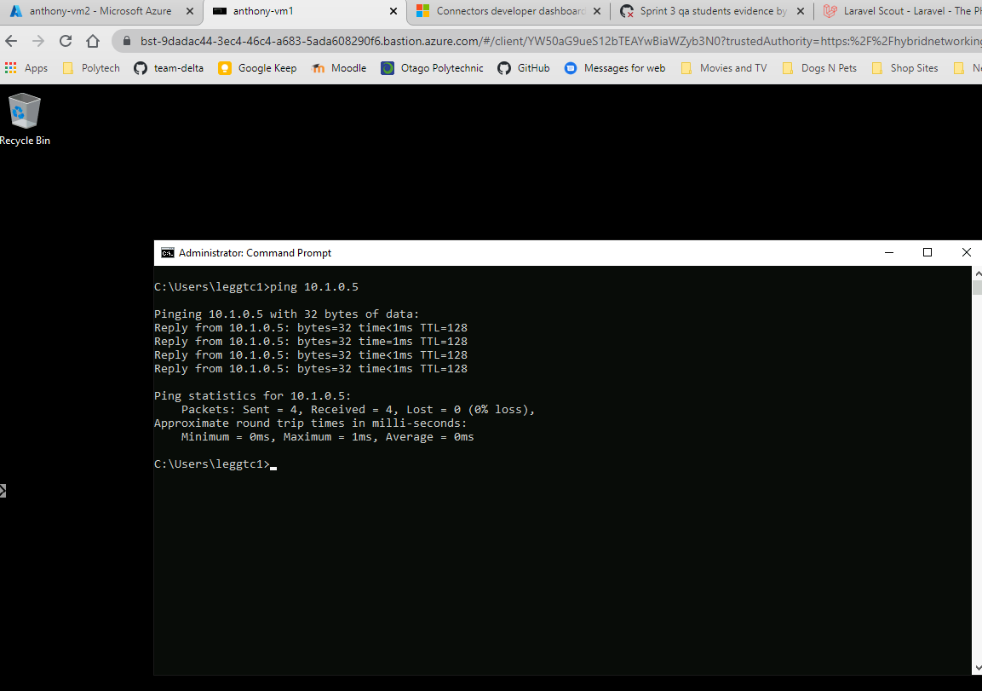

**Q3. Draw a diagram showing the VN, subnets, Bastion host and VM1 and VM2**

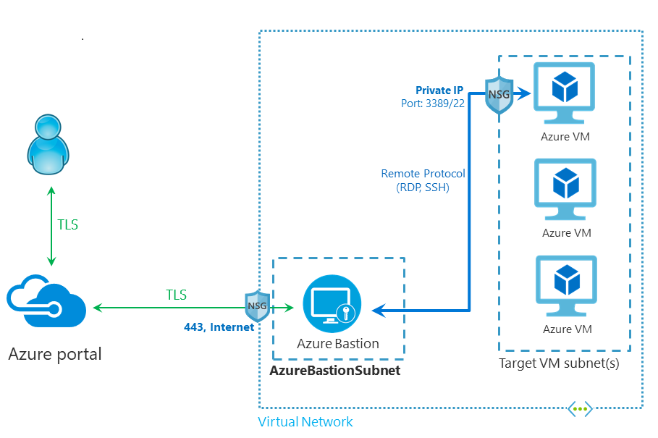

**Exercise 2: How to create and Manage network Security groups**

(Hints: <https://docs.microsoft.com/en-us/learn/modules/secure-and-isolate-with-nsg-and-service-endpoints/3-exercise-network-security-groups>)

Part 2: Reflective Questions

1. What can you do with network security groups?
2. Why did you configure two security groups in the exercise?